Bouncing BallS Simulator
A Level Computer Science NEA

Bob Smith 1234
Harington School 24345

Contents
Analysis 2
Context of Problem 2
Interview 2
Existing System 2
Requirements 2
Acceptable Limitations 2
Success Criteria 2
Qualitative Criteria 2
Quantitative Criteria 2
Documented Design 3
Description 3
Interface Design 3
Algorithms 3
Technical Solution 4
Testing 5
Test Table 5
Evidence 5
Evaluation 6
Analysis of Criteria 6
End User Feedback 6
Final Thoughts 6

Analysis

Context of Problem
This section should contain the background to the problem – if it is for use within the school, give the background to the school, along with a photo. If there is any maths or background information that is needed in order to understand your project it include it here (with a subheading)

Analysis of Problem
Explain the problem that currently exists and why it is a problem

Interview
Introduce your end user and give an interview with them, analyse the interview at the end, explaining what has been learned (“From the interview any solution to this problem would need to be ….”)

Existing System
Give some scans of existing work/textbooks/products that exist that are relevant to your problem. Annotate and analyse them to point out what features should be used in any solution to the problem

Identification of Users
Who will be using your system? What is their expertise level, how will they be using it, what impact does this have on any design? Does the end user know their way around a computer, or does the solution need to be designed to be fool-proof? If it’s used only by a teacher to demo to a class on a whiteboard, then it needs big buttons and sliders so it can be operated on the screen. If it’s used by students on their computers, how does that effect the design? If it’s used by both, how does it need to adapt?

Requirements
Summarise everything above to explain what is required by any solution to this problem – this section is still a discussion, not formal, but everything the solution needs should be mentioned (and justified) here
“from the interview, it is clear that the product needs a simple interface that can be operated with a touchscreen… from the existing system, a design where the working is shown throughout would be helpful…”

Acceptable Limitations
Exaplain what limitations the product can have. For example an orbit simulator can be 2D only, and can treat planets as point masses.

Success Criteria
Give a formal numbered list of everything the product must have to be considered a success. At the end of the project, you will judge the success on whether or not you can tick off these criteria, so they must be exhaustive – it should not be possible for a lazy programmer to make a rubbish product that meets your criteria

Qualitative Criteria
Criteria that are subjective, such as “it must be easy to use”

Quantitative Criteria
Criteria that are objective such as those below:
- The program must show a simulation of up to 100 balls
- The balls must respond realistically to gravity
- The balls must bounce of the sides of the screen
- The user must be able to change the gravity

Documented Design

Description
Give a paragraph describing your proposed solution
To solve the problem, I intend to make a ….

Interface Design
Annotated sketch diagrams showing how you intend your product to work. This should be detailed enough that you could give it to a programmer, and they could make it without having to ask you how things work.
The balls will move around the area bouncing off the….
When clicked this button will….

Class Structure
A full UML diagram of your planned product
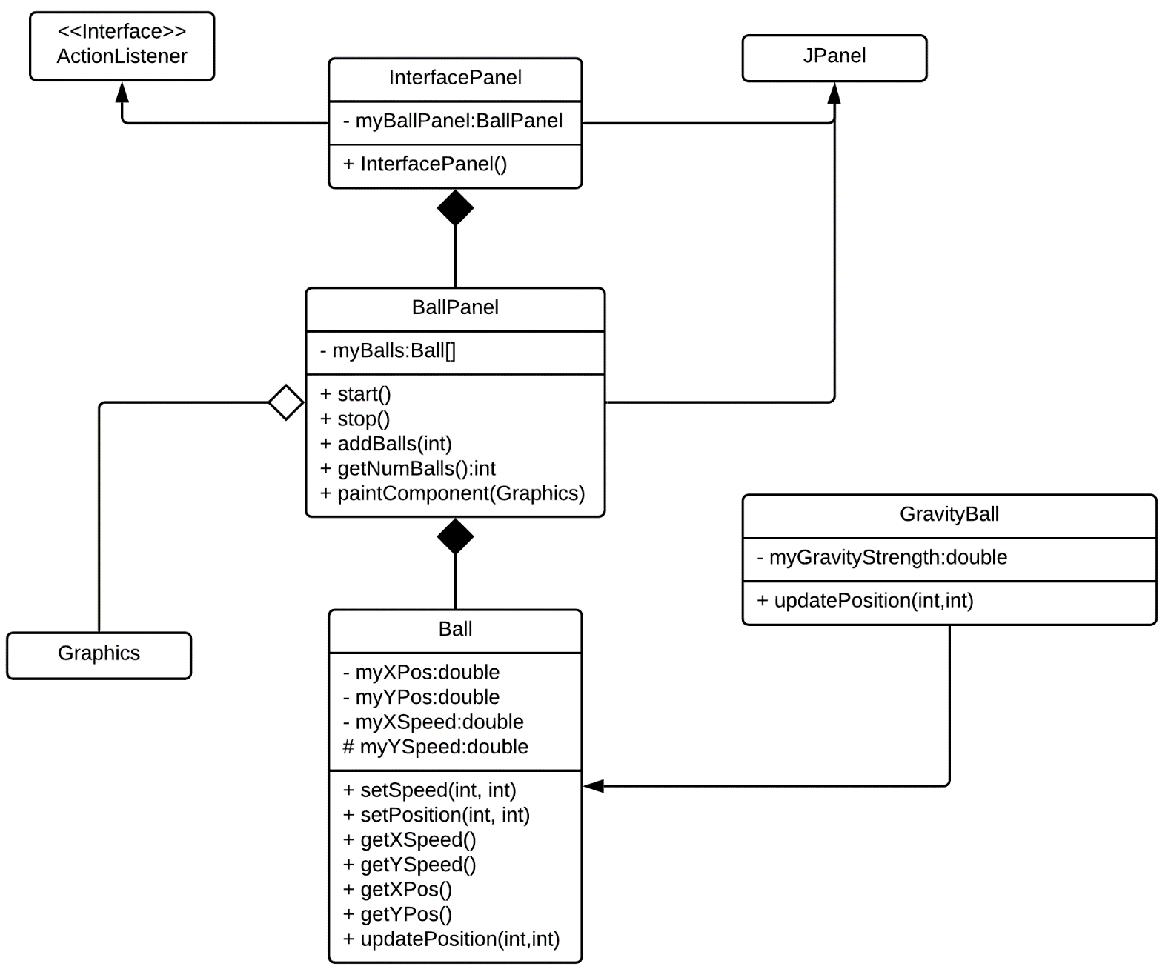

Algorithms
Each class should be broken down into methods, with a description of the purpose of each method. Where appropriate, annotated pseudocode should be used to explain how the method will perform its function

Class: Ball
This class contains all the methods and attributes for a single ball

Method: UpdatePosition
This method is called each frame update and will update the ball’s position according to it’s speed values. If the ball encounters a wall it will bounce off it
Checks if the x position of the ball has gone past the right edge of the viewable area, and multiples it by -1, simulating bouncing.
Xposxpos+xpeed
Yposypos+yspeed
if xpos > right wall
xpos xpox*-1
...

Method: PaintComponent
This is used to draw the balls in their current position

For each ball in list as BALL do
Set colour (Ball.colour)
drawCircle(Ball.xPosition, Ball.yPosition, width, height)
Set colour (Black)
drawCircleOutline(Ball.xPosition, Ball.yPosition, width, height)
This draws an outline in the same position of the ball in order to give it a black border
call ballPanel()

Technical Solution
This section is completed after the program is made and shows how it works

Final product
Annotated screenshots of your program explaining how it works (should roughly mirror your sketch diagrams from the design section)
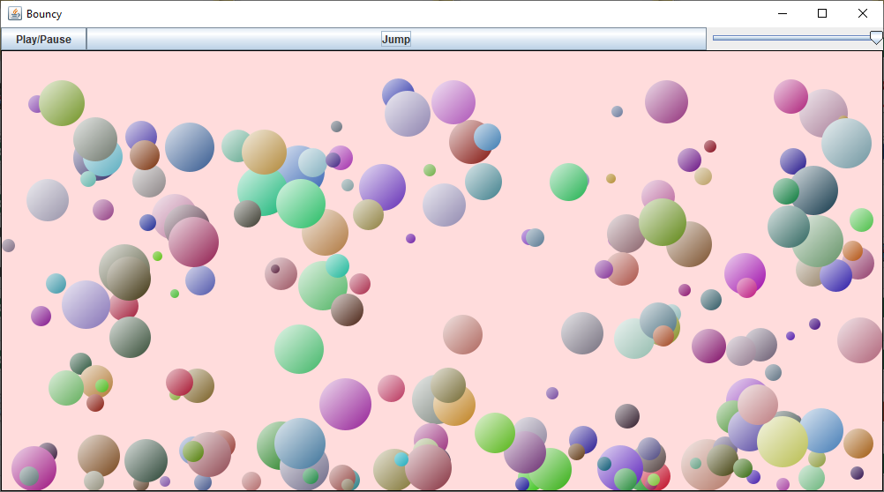
The balls move around the area bouncing off the….
When clicked this button does….

Code Segments
This section should mirror the algorithm design, but now shows annotated code sections, explaining how they work. Not every line of code needs to be included, just the ones worth explaining.

Class: Map

LoadLevel

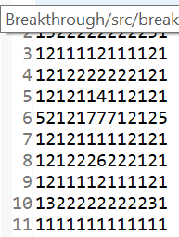
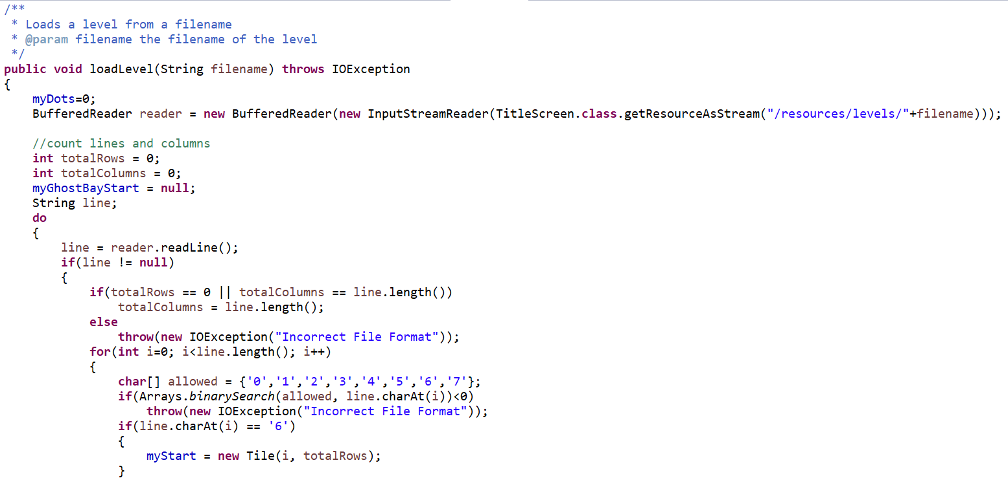
Example of a level text file
Create a Buffered Reader to read the level text file
Throws an IOException if the file is not valid

Testing
A test should be designed for each success criteria, and should be enough to evidence that the program fully works and meets all the success criteira

Test Table
Test Number | Success Criteria | Description | Expected outcome | Observed outcome | Remedial action (if necessary)
1 | 1 | Launch application, and start 1 player game | First level loads with a single yellow pacman | Game successfully started with one playe | None needed
2 | 1 | Launch application, and start 2 player game | Fist level loads with yellow and green pacman
3 | 2 | On menu screen, press left to change p1 colour and “a” to change p2 colour and start game | Both players should be their new colours
4

Evidence
Screenshot evidence where appropriate for each test

Test 1
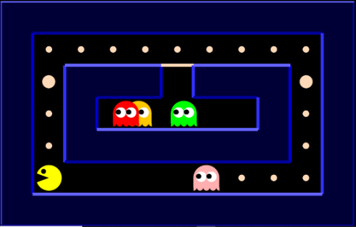

Test 2
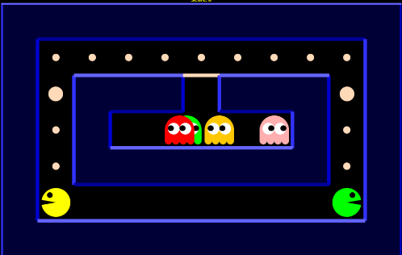

Evaluation

Analysis of Criteria
Include each of your success criteria along with a description (and reference to evidence if possible) with how you met it

End User Feedback
Include some feedback from your end user and analyse it to explain how successful your product was

Furhter development
If the product were to continue to be developed, how could this be done? What could be added or improved?

Final thoughts
Overall, how do you feel about your product and the experience of making it? (be positive)

